Project Development Phase
Data Preprocessing Steps
- Data Collection
- Downloaded the EV dataset in CSV/Excel format.
- Verified the dataset completeness and structure.
- Ensured attributes like vehicle type, range, charging time, price, and location are available.
- Understand the Dataset
- Identified column names and meanings.
- Checked data types (numeric, text, date).
- Identified missing values and inconsistencies.
- Reviewed business questions related to EV adoption and charging infrastructure.
- Import Dataset into Database / Spreadsheet
- Loaded dataset into MySQL / Excel / Tableau.
- Validated a successful import.
- Ensured no data truncation or format issues.
- Connect Tableau Desktop to Database Server
- Established connection between Tableau and data source.
- Verified tables and fields are visible.
- Checked relationships if multiple tables are used.
- Data Preparation
- Remove Duplicate Records
Eliminated repeated entries.
- Handle Missing Values
Replaced null numeric values using average/median.
Replaced missing categorical values with mode or default label.
- Correct Data Types
Converted text fields to numeric where required.
Formated date columns properly.
Ensured price and range fields are numeric.
- Data Standardization
Standardized units (km, hours).
Normalized state or city names.
Format currency properly.
- Create Calculated Fields in Tableau
Range Efficiency
Charging Speed Ratio
State-wise EV count
Average price per region
- Filtering & Cleaning
Removed unnecessary columns.
Filtered irrelevant or outlier records.
- Data Validation
- Cross-checked totals and aggregations.
- Ensured no null values affecting visualizations.
Dashboard

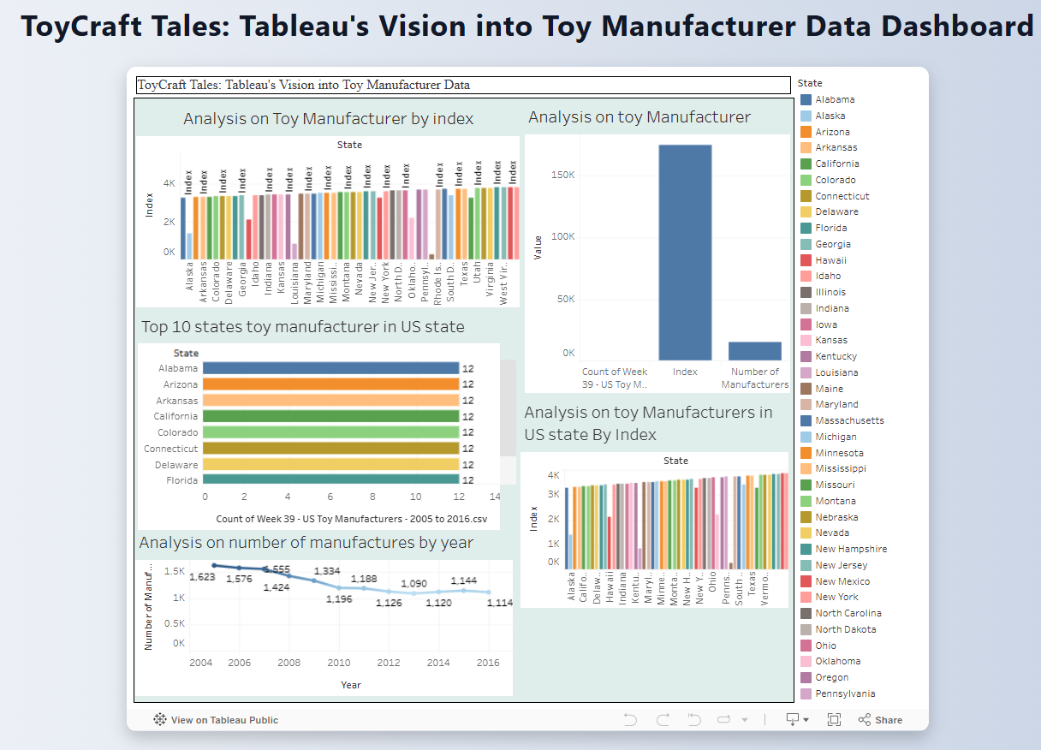

Story
